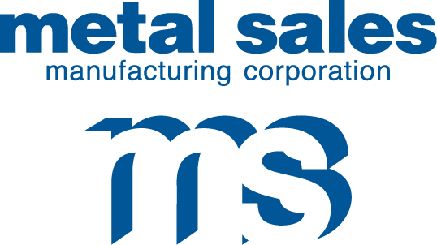

7800 State Road 60

Sellersburg, IN 47172

Phone: 800.999.7777

812.246.1866

Fax: 812.246.0893

www.metalsales.us.com

**Metallic Waiver Acknowledgement**

**Date: Click here to enter a date.**

**Project ID/SO Number:**

**Project Name:**

**Click here to enter text. has requested Metal Sales Manufacturing Corporation (MSMC) produce Click here to enter text.**

**MSMC needs you to be aware that metallic paint systems are not intended to be mixed in wall/roof panel applications due to potential variations in sheen presentation.**

**The replacement panel requested above will not be produced out of the same batch of coil from which the original order was produced. This may result in a variation in presentation.**

**By signing this form, you acknowledge an understanding of potential variation. You acknowledge that all parties concerned in this transaction have been notified, including the end user, that the potential for sheen variation does exist and that this sheen variation is not reason for production rejection and/or return of product.**

**Company Name: __________________________________**

**PO#: __________________**

**Printed Name: ____________________________________**

**Title: _______________________________**

**Signature: _____________________________________**

**Date: ___________________**

Contact for Questions or Concerns

CIA Sellersburg Hub

E-Mail: [CIASellersburg@metalsales.us.com](mailto:CIASellersburg@metalsales.us.com)

Phone: (812)-748-8058

Individual Highlights:

Inside Story 2

Inside Story 3

Inside Story 4

Inside Story 5

Inside Story 6

Inside Story 7

Last Story 8

Special Interest Articles:

* Briefly highlight your point of interest here.
* Briefly highlight your point of interest here.
* Briefly highlight your point of interest here.